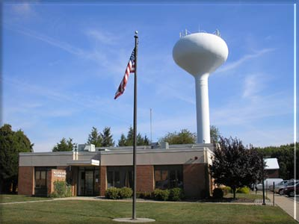
Upper Southampton Municipal Authority
945 Street Road, P.O. Box 481
Southampton, PA 18966
(215) 364-1390 Fax (215) 364-9410

CERTIFICATION REQUEST

Property address ________________________________________________________

Seller(s) Name(s) _______________________________________________________

Seller Phone ____________________ Seller email_____________________________

Forwarding address______________________________________________________

______________________________________________________________________

Date of Settlement_____________ Title Co./Conveyancer _______________________

Certification sent to ______________________________Realtor Name ____________

Fax # ___________________________________ Time of Settlement ________ am pm

Buyer Name(s) __________________________________________________________

Buyer Phone____________________ Buyer email ______________________________

Office Use Only
Account #____________ Final Read_________Sump Inspect____Lateral Inspect______

Notes:___________________________________________________________________

_________________________________________________________________________

_________________________________________________________________________

_________________________________________________________________________
UPPER SOUTHAMPTON MUNICIPAL AUTHORITY

